**ESIGELEC ONLINE SALES**

This site is to design for ESIGELEC online sales for Electronic products. It is categorized into several different parts:

Categories (Laptops, Cameras, Mobiles, Computers, tablets, iPads, Watches) Each product have its brand name

Brands (HP, DELL, Apple, Samsung, Sony, Oppo, Leovo, Toshiba)

Every product has its Details. where you can find an option to Delete product.

There is several menu buttons.

Such as Home, MyAccount, Cart, and Insert Product.

Inside My Account we have several options (My Wish List, My Orders, Logout)

Whereas Insert Product is only available for Admin to Insert Product In list of Categories.

Technologies Uses: Font end:

1. HTML
2. CSS
3. JavaScript

Back-end:

1. PHP

Server: EasyPhpMyAdmin.

There is another features that user can register on this site.

Screenshot of Site:

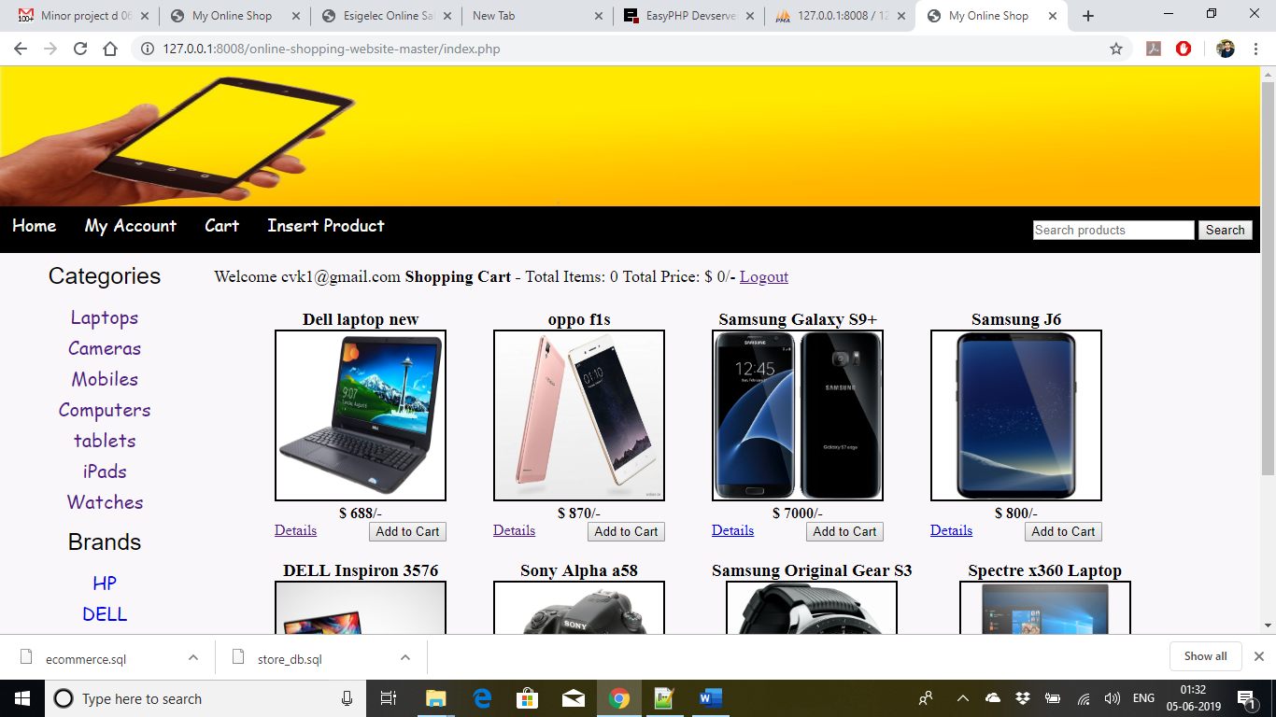

Database:

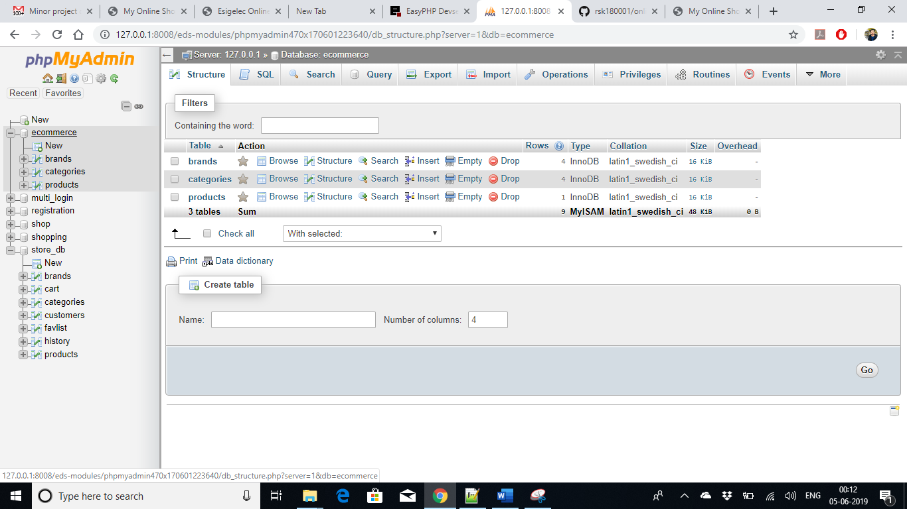

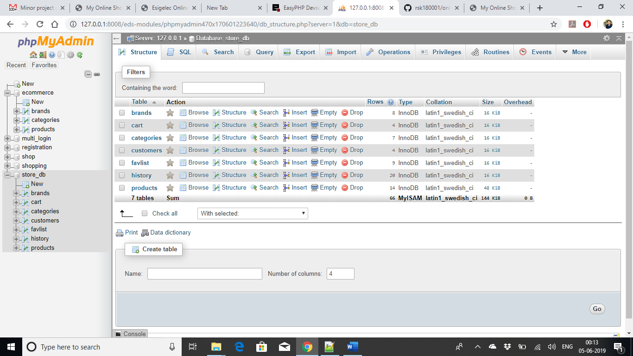

Admin Login:

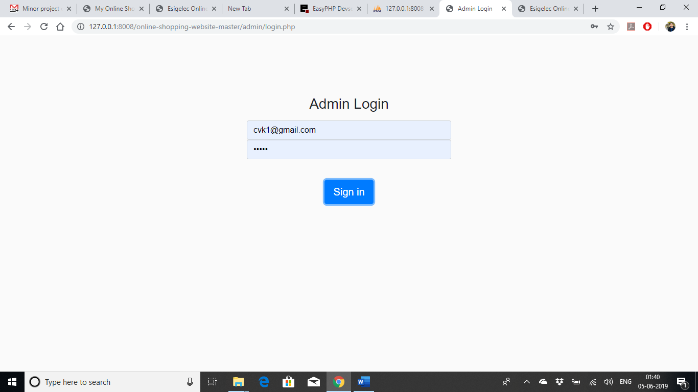

User Register Page:

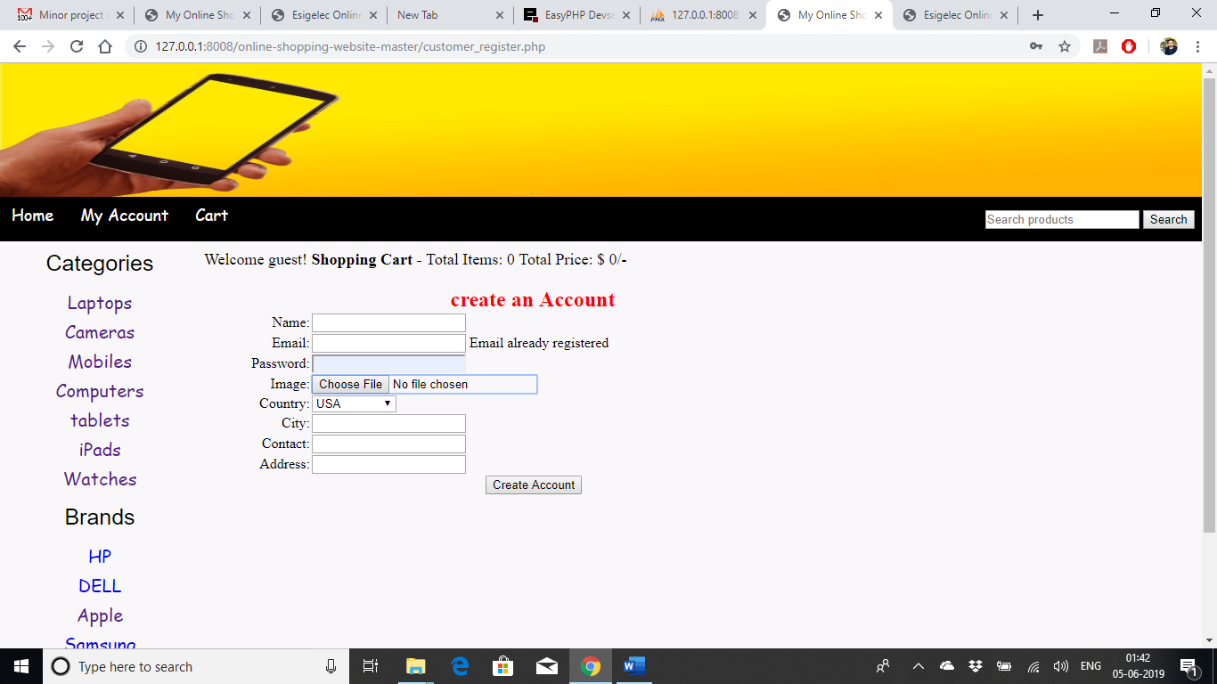

Thank You!!